CHAPTER 1
INTRODUCTION
An Automated Robotic Arm is a mechanical system designed to perform tasks automatically with high precision and efficiency. This project uses an ESP32 microcontroller and servo motors to control the movement of the robotic arm. The system can perform operations such as picking and placing objects without continuous human effort. Robotic arms are widely used in industries to improve productivity and reduce manual work. This project helps in understanding the basics of robotics, automation, and embedded systems.
1.1 Brief History of Automated Robotic Arm
The concept of health monitoring began with manual observation and basic medical instruments such as thermometers and stethoscopes, which were used by healthcare professionals to assess a patient’s condition during clinical visits. In the early 20th century, medical devices such as electrocardiograms (ECGs) were introduced, allowing more accurate monitoring of heart activity, but these systems were large, expensive, and confined to hospitals.
The idea of robotic arms originated from the need to automate repetitive and dangerous industrial tasks. In the early 1950s, engineers started developing programmable machines capable of performing human-like movements. The first industrial robotic arm, was introduced by George Devol and Joseph Engelberger in 1961 and was mainly used in automobile manufacturing industries. During the 1970s and 1980s, robotic arms became more advanced with the integration of computers, sensors, and electronic control systems. The development of microcontrollers and embedded systems further improved the flexibility and precision of robotic arms. In recent years, robotic arms have been widely used in medical surgeries, laboratories, warehouses, and space exploration. Modern automated robotic arms now use technologies such as artificial intelligence, machine learning, and IoT for smart and efficient operation.

CHAPTER 2 Problem Statement
2.1 Description
The Automated Robotic Arm is a programmable mechanical device designed to perform tasks automatically. It uses an ESP32 microcontroller to control the movement of servo motors in different directions. The robotic arm can pick, place, and move objects with accuracy and efficiency. The system reduces human effort and increases productivity in repetitive tasks. This project demonstrates the application of robotics, automation, and embedded system technology.
  - Challenge Statement
Industries often face difficulties in performing repetitive tasks with high accuracy and efficiency. Manual handling of objects can lead to errors, increased labor costs, and reduced productivity. There is a need for an automated system that can perform such tasks safely and precisely. Designing a robotic arm with smooth movement and proper control is a major challenge. This project aims to develop a cost-effective automated robotic arm using ESP32 and servo motors to overcome these issues.

CHAPTER 3
3.1 Design Thinking Process
1.Empathize:
Workers performing repetitive tasks often experience fatigue and reduced efficiency over time. Industries require a reliable and accurate system to minimize human effort and improve productivity. An automated robotic arm can help perform repetitive operations safely, quickly, and efficiently.
2. Define
The problem is to design an automated robotic arm capable of performing repetitive tasks with accuracy and minimal human intervention. The system should provide smooth movement, efficient object handling, and reliable operation. The project focuses on developing a low-cost and programmable robotic arm using ESP32 and servo motors.
3. Ideate
Different ideas were explored to improve the movement, control, and efficiency of the robotic arm. ESP32 and servo motors were selected for easy programming and precise motion control. Additional features such as wireless control and sensor integration were also considered for future improvements.
4. Prototype
A prototype robotic arm was developed using an ESP32 microcontroller, servo motors, and a mechanical arm structure. The components were assembled and programmed to perform basic pick-and-place operations. Initial testing was carried out to check movement accuracy and system performance.
5.Test
The robotic arm was tested for accurate movement and gripping performance.
Servo motors responded correctly to the programmed commands during operation.
The system successfully completed automated pick-and-place tasks.
6.Implement and Iterate
The robotic arm was implemented using servo motors, Arduino, and a mechanical arm structure to perform automated pick-and-place operations. Programming was developed to control the movement of each joint accurately. Several iterations were carried out to improve gripping strength, movement precision, and overall stability. Continuous testing and modifications helped achieve smoother and more reliable performance of the system.

3.2 METHODOLOGY
The methodology for developing the automated robotic arm began with identifying the project requirements and objectives. A suitable mechanical design was selected to provide multiple degrees of freedom for movement. Servo motors were chosen for accurate joint control and smooth operation. An Arduino microcontroller was used to program and control the robotic arm movements. The mechanical parts were assembled using brackets, arm links, and a gripper mechanism. Electrical connections were made between the servos, power supply, and controller board. Programming was developed to automate pick-and-place operations through predefined motion sequences. Sensors were optionally integrated for object detection and automation. The robotic arm was tested repeatedly to evaluate movement accuracy, gripping capability, and stability. Necessary modifications and iterations were performed to improve the overall performance and reliability of the system.
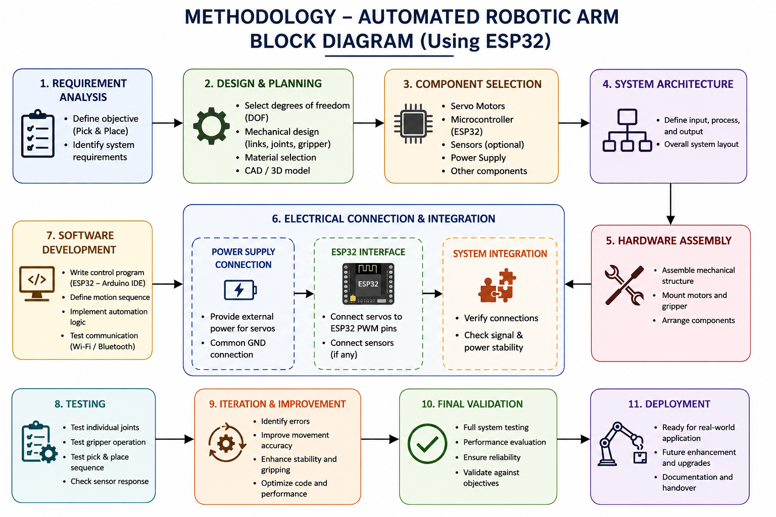
3.3 Prototype Description
Materials Used
- ESP32 microcontroller
- Servo motors (MG996R and SG90)
- Robotic arm frame kit
- Servo brackets and arm links
- Gripper mechanism
- Breadboard and jumper wires
- 5V power supply or battery
- Nuts, bolts, and screws
- IR sensor
- USB cable and programming software

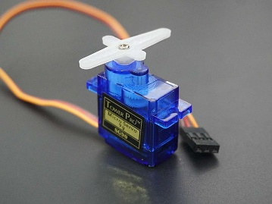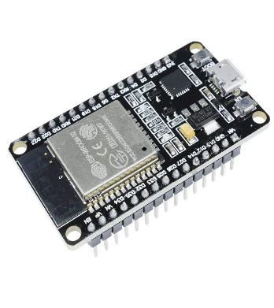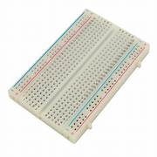
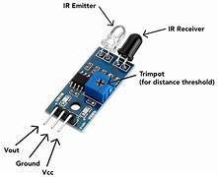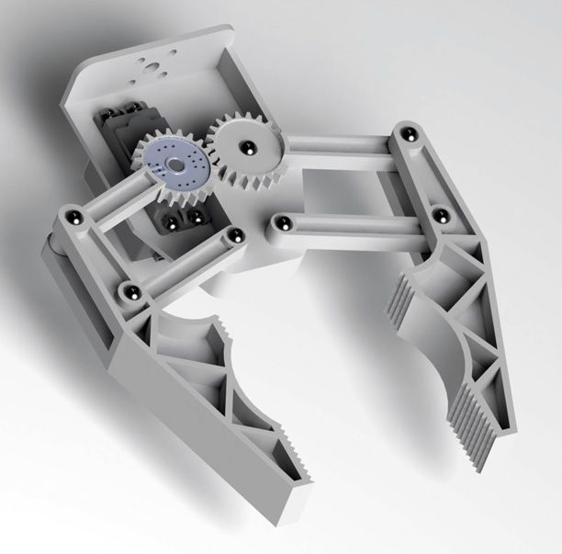

3.4 CIRCUIT CONNECTION (DIAGRAM)
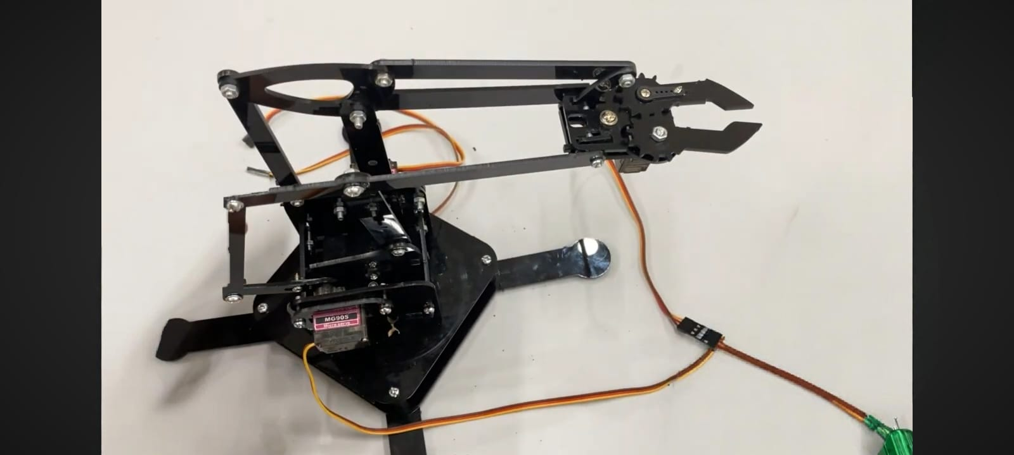
Chapter 4
Implementation
Program: #include <ESP32Servo.h>

// Create servo objects
Servo baseMotor; // MG995R
Servo shoulderMotor; // SG90
Servo elbowMotor; // SG90
Servo gripperMotor; // SG90

// IR Sensor Pin
const int irSensor = 15;

// Servo Pins
const int basePin = 13;
const int shoulderPin = 12;
const int elbowPin = 14;
const int gripperPin = 27;

void setup() {

Serial.begin(115200);

// Attach servos
baseMotor.attach(basePin);
shoulderMotor.attach(shoulderPin);
elbowMotor.attach(elbowPin);
gripperMotor.attach(gripperPin);

// IR sensor input
pinMode(irSensor, INPUT);

// Initial Position
baseMotor.write(90);
shoulderMotor.write(90);
elbowMotor.write(90);
gripperMotor.write(90);

delay(2000);
}

void loop() {

int sensorValue = digitalRead(irSensor);

// Object detected
if (sensorValue == LOW) {

Serial.println("Object Detected");

// Move arm to object
baseMotor.write(90);
shoulderMotor.write(60);
elbowMotor.write(120);

delay(1000);

// Close gripper
gripperMotor.write(40);

delay(1000);

// Lift object
shoulderMotor.write(100);
elbowMotor.write(80);

delay(1000);

// Rotate base
baseMotor.write(150);

delay(1000);

// Open gripper
gripperMotor.write(90);

delay(1000);

// Return to home position
baseMotor.write(90);
shoulderMotor.write(90);
elbowMotor.write(90);

delay(2000);
}

else {

Serial.println("No Object");

// Idle position
baseMotor.write(90);
shoulderMotor.write(90);
elbowMotor.write(90);
gripperMotor.write(90);
}

delay(500);
}

Chapter 5
Results and Analysis
5.1 Observation
The automated robotic arm operated successfully and was able to perform pick-and-place tasks with good accuracy. The servo motors responded properly to the control signals from the microcontroller, enabling smooth movement of different joints of the arm. The gripper mechanism effectively held and released objects without major errors. The system reduced manual effort and demonstrated how robotics and automation can improve efficiency in industrial and repetitive tasks. The project also showed the practical application of embedded systems, sensors, and motor control in real-world automation systems.

Chapter 6
CONCLUSION AND FUTURE WORK

Conclusion
The Automated Robotic Arm project was successfully designed and implemented to perform automatic pick-and-place operations efficiently. The system demonstrated accurate movement and proper coordination between the microcontroller, servo motors, and gripper mechanism. It reduced human effort in repetitive tasks and showed the importance of robotics and automation in industrial applications. The project also helped in understanding embedded systems, motor control, and real-time automation techniques.

Future Work
In the future, the robotic arm can be improved by adding artificial intelligence and machine learning for smarter object detection and decision-making. Wireless control using mobile applications or IoT technology can also be implemented for remote operation. The arm can be upgraded with stronger motors and advanced sensors to handle heavier and more complex tasks. Camera modules and image processing techniques can also be added to improve accuracy and enable fully automated industrial applications.

REFERENCES
- Arduino Official Website – Reference for microcontroller programming and robotic arm control.
- Servo Motor Tutorial – Used for understanding servo motor connections and working.
- Robotics and Industrial Automation study materials, IEEE journals, and embedded systems reference books were used for project development.

Department of Computer Science Engineering Academic Year: 2025–26

I’ve prepared a sample project report for an ESP32-based AUTOMATED ROBOTIC ARM in the same format and style as the report you shared (chapter-wise, formal academic tone, suitable for college submission).

